THE POWER IS IN YOUR HANDS
Your Vote for Efficient Building Codes Will Strengthen America’s Energy Policy

Action Alert to <Your COG or Jurisdiction>:
You MUST register your ICC Governmental Member Voting Representatives by:
September 19!

Act now to secure your jurisdiction’s maximum voting rights to improve America’s Model Energy Code this November!

An opportunity: The Energy Efficient Codes Coalition (EECC) is working with <COG/Jurisdiction> to alert you and your jurisdiction to an opportunity to vote for more efficient buildings in this fall’s 2018 International Energy Conservation Code (IECC) update. The IECC is the basis for the energy code in Texas and in 40+ states. The last three IECCs boosted efficiency for new homes and commercial buildings by over 30%!
Project Partners
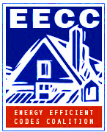
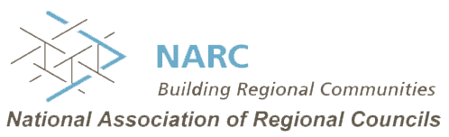
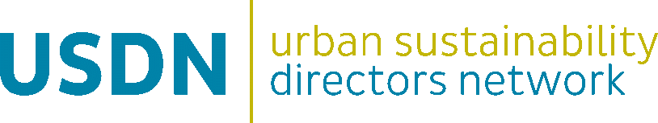
Join with us in
this important national energy policy initiative!

The power is in your hands: The IECC—America’s Model Energy Code—is updated every three years in a year-long process that culminates with electronic voting by Governmental Member Voting Representatives (GMVRs) of the International Code Council (ICC). GMVRs are appointed by local governments like yours and are usually code officials, building inspectors, fire marshals, sustainability/policy staff, and other qualified individuals.

The threat: November’s electronic ICC ballot will contain over two dozen proposals that will rollback or trade away recent landmark efficiency gains and there are precious few proposals that boost efficiency. If rollbacks prevail, the 2018 IECC will be the first in history to be weaker than the code it updates, jeopardizing support from DOE and from efficiency experts who agree that steady progress is key to meeting long-term sustainability goals. We’re urging <COG/Jurisdiction> to help us defeat the rollbacks and put the 2018 IECC on a glide path of progress.

The US Conference of Mayors (USCM) unanimously endorses the goals of our campaign to boost the 2018 IECC by 5%!

In June, the mayors adopted a resolution to put the 2018 and future IECCs on a glide path of steady progress. The resolution calls for: (a) A modest 5% energy efficiency increase in the 2018 IECC, (b) Opposing measures that roll back efficiency requirements or weaken the code, and (c) Encouraging municipal support for all eligible GMVRs to vote in favor of continued efficiency gains for America's Model Energy Code and, if possible, to attend the ICC hearings in Kansas City. EECC encourages CAPCOG’s members to support the USCM resolution and take the necessary steps to participate in this process.

The fact sheet accompanying this Action Alert spells out the procedural steps you need to take to ensure that ALL of your jurisdiction’s 4, 8, or 12 GMVRs have the proper credentials to cast their votes (the number of votes depends on population. See instructions).

<Jurisdiction> Metro area local governments <belonging to COG> can do their part to strengthen the IECC by:

- Registering to vote and securing voting credentials as an ICC Governmental Member Voting Representative by September 19
- Testifying and casting important procedural “hand votes” in-person at ICC’s Public Comment Hearings in Kansas City (October 19-25). These important votes set the agenda for November’s on-line voting.
- Casting your on-line ballot with cdpACCESS for code measures that improve efficiency and prevent rollbacks) during the on-line voting period, November 8-21. These votes determine the new IECC.

The Energy Efficient Codes Coalition’s The Power is in Your Hands code campaign web site at: http://energyefficientcodes.com/power/ can help <Jurisdiction/COG members> understand policy and technical issues related to the 2018 IECC development and how they can participate most effectively in the process. The site includes useful information such as recorded webinars and presentations, policy papers and advocacy materials and links to the USCM resolution. EECC also offers educational webinars on using cdpACCESS, energy code development policy, and other timely IECC topics. <We/COG> will notify you of these educational webinars. In addition, EECC’s voting recommendations will be circulated prior to ICC’s Kansas City hearings and online voting window.

An Invitation to Join With Us and Our Campaign

EECC and our outreach team members invite you and your local government to join with us to bring this campaign to the local level through your city or town, or through your local council of governments. Your local governmental unit should consider the following actions:
- Distribute campaign event announcements to your local government and code official email lists
- Promote national energy code information webinars by ICLEI and others
- Arrange and host cdpACCESS training sessions for the ICC’s online voting system
- Facilitate ICC voting rosters and voting credentials
- Send delegates to the ICC code hearing in Kansas City
- Distribute the EECC voting guide and summary recommendations to local code officials.

For more information on the 2018 IECC Campaign and how to participate, please contact us through your preferred membership organization or network:
Energy Efficient Codes Coalition (EECC) | Harry Misuriello | hmisuriello@aceee.org
ICLEI Local Governments for Sustainability (ICLEI USA) | Riana Ackley | Riana.ackley@iclei.org
National Association of Regional Councils (NARC) | Anna Rosenbaum | anna@narc.org
Urban Sustainability Directors Network (USDN) | Garrett Fitzgerald | garrettfitzgerald@usdn.org

